**Procedure for AltimeterGUI.m**

The AltimeterGUI is a MATLAB interface for the ASEN 2004 Water Bottle Rocket Lab altimeter payload. The GUI’s functions include:

1. *Checking the altimeter status to verify if a flight was correctly saved*
2. *Downloading, saving, processing, and plotting of launch data*
3. *Erasing the flash memory to prepare for a new launch*
4. *Sending a launch command without the RBFP to perform bench-top testing*
5. *Streaming data from the altimeter to perform bench-top testing*

**Set-up Procedure:**

1. Power on the altimeter by connecting it to a battery.
2. Connect the altimeter to the computer USB port via an FTDI cable. (*Note: the FTDI cable does not power the altimeter, it is only for serial communication*).
3. Run the GUI in MATLAB by calling the AltimeterGUI.m function.

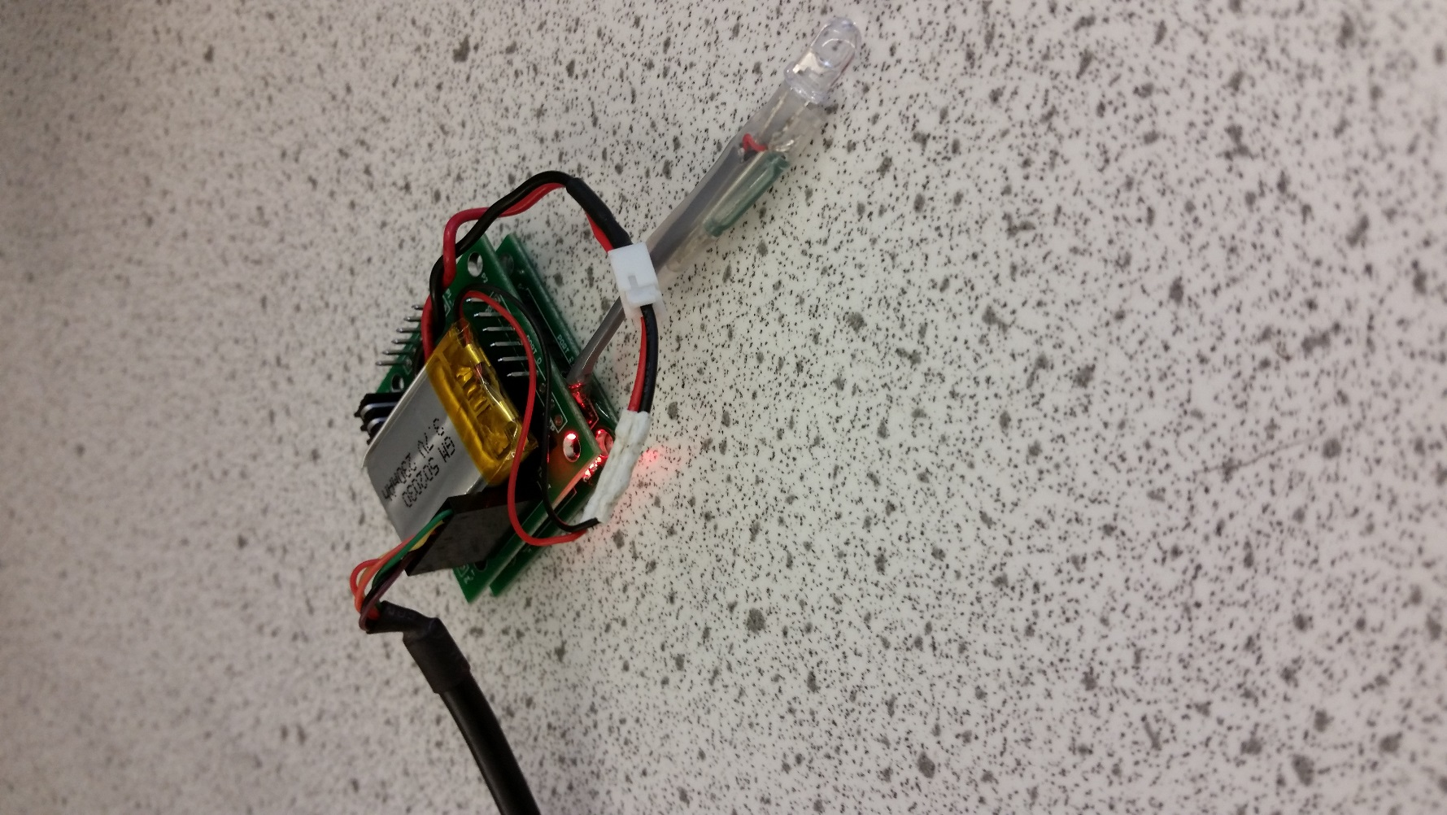

**RBFP LED connected to RBFP Reed Switch. Flashing fast when erased and ready for flight.**

**Battery connection – this is a keyed connector for 3.7V LiPo batteries**

**FTDI connection – green cable is on side towards idle LED**

**Idle LED – should be flashing red when altimeter is powered**

1. Check the status of the altimeter using the GUI

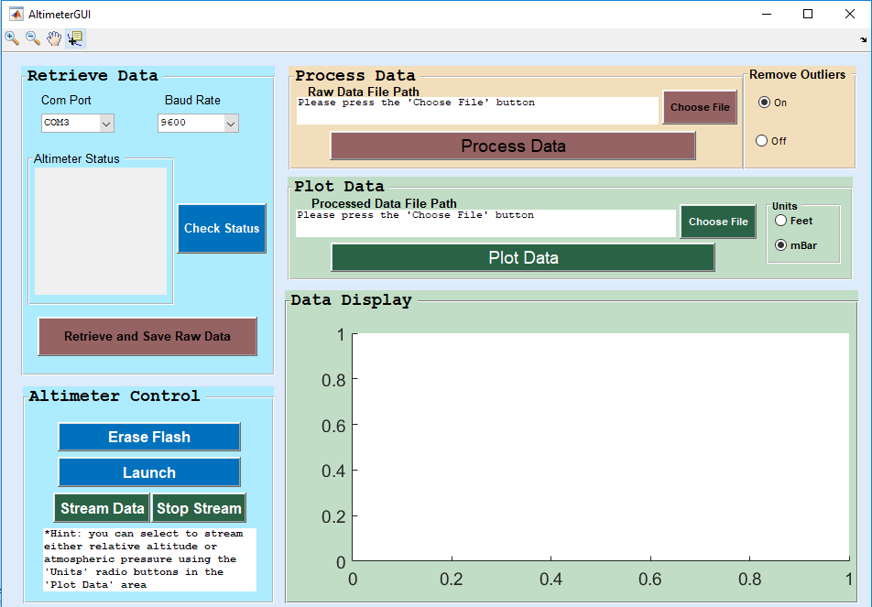

In the command window, you should see something similar to the following:

30-Mar-2015 14:09:23 -- Requesting Altimeter Status...

30-Mar-2015 14:09:23 -- Current Altimeter Status: ERASED (E)

If you receive the message that the altimeter status is launched, that is also fine. If you get an error that an unknown response was received, then check all cables to make sure the altimeter is properly connected. If the problem persists then contact Trudy Schwartz or Bobby Hodgkinson.

*An error may occur if you have another USB device plugged into the computer you are using. You can ensure that the COM port the GUI is selecting is for the altimeter by checking the device manager on Windows or unplugging other USB devices. If you unplug other USB devices, you may need to restart the GUI.*

**GUI Button Definitions:**



1. **Check Status** – This button checks the current status of the altimeter. The altimeter should respond with a single character such as ‘E’ or ‘L’ which correspond to “flash erased” or “launch data written to flash”, respectively. This is shown in the command window.
2. **Retrieve and Save Raw Data** – This button downloads raw data from the altimeter and saves it to a file specified by the user. If there is no launch data written to the flash memory then you will get junk data as the altimeter just dumps whatever data is in its memory.
3. **Erase Flash** – This button sends the ‘WIPE’ command to the altimeter which clears its flash memory. You should see the following in the command window:

30-Mar-2015 15:01:28 -- Sent WIPE command

30-Mar-2015 15:01:28 -- Waiting for response...

30-Mar-2015 15:01:28 -- Got response: Memory Has Been Erased!

30-Mar-2015 15:01:29 -- Requesting Altimeter Status...

30-Mar-2015 15:01:29 -- Current Altimeter Status: ERASED (E)

A common error occurs when the altimeter does not respond with the full “Memory Has Been Erased!” phrase. However, as long as when the GUI automatically checks the altimeter status it gets an “ERASED” response, the memory was successfully wiped. If the orange RBFP LED turns on when the erase flash button is pressed, there is likely a problem with the RBFP Reed Switch and it needs to be replaced.

NOTE: RBFP LED will flash fast when the memory is erased and ready for launch, is solid on when logging data, and will flash slow when the memory is full with launched data.

1. **Launch** – This button sends the launch command for the altimeter in order to perform bench-top testing. When this button is pressed the RBFP LED should turn on solid for 30 seconds of logging and then automatically turn off. The GUI will tell you if the altimeter was unable to launch due to a flight already being written to the flash memory. You can use the **Retrieve and Save Raw Data** and **Process Data** buttons to analyze the data.
2. **Stream Data** – This button allows the GUI to stream pressure readings from the altimeter. The data is shown in the “Data Display” area of the GUI. If the “Feet” radio button in the “Units” area of the GUI is selected, then the GUI automatically converts the pressure data into relative altitude for benchtop testing. The streaming data does not use temperature compensation, so the data will drift. The RBFP LED should turn off while the altimeter is streaming data. The **Stop Stream** button must be pressed or the altimeter must be power cycled to stop streaming data.
3. **Stop Stream** – This button tells the altimeter to stop streaming pressure readings. The RBFP LED should return to its previous blinking state when this button is pressed. If the LED does not return then try pressing the button again or unplugging the altimeter battery and contact Trudy Schwartz or Bobby Hodgkinson.
4. **Process Data Choose File** – This button allows the user to select which raw altimeter data file they would like to process. It should be noted that when the **Retrieve and Save Raw Data** button is used it automatically sets the raw data file path to the data file that was just retrieved.
5. **Process Data** – This button processes the file shown in the raw data file path field and converts it to pressure and temperature readings. The GUI uses the raw data file name and appends ‘_processed_smoothed’ or ‘_processed_notSmoothed’ depending on the options selected in the remove outliers pane. This new processed data file is saved in the same directory as the raw data file seleced. The altimeter calibration coefficients that were read from the altimeter’s flash memory are displayed in the command window, along with the data duration as shown below:

========================================================

==================== B16_raw_bench1 ====================

Parsed Altimeter Calibration Coefficients:

46967

48719

28193

25329

31702

27395

Total time of data set: 30.0 seconds

========================================================

========================================================

(*Note: The parsed altimeter calibration coefficients will be different for different altimeters and also for different tests*).

The processed data is then displayed to the user in the “Data Display” area of the GUI. It should be noted that the processed data file path field is automatically updated to be the file that was just processed.

The data file contains timestamps in seconds, pressure in mBar, and temperature in $°$ C and can be loaded into MATLAB with a simple ‘load’ command.

1. **Plot Data Choose File** – This button allows the user to select which processed altimeter data file they would like to plot. It should be noted that the processed data file path field is automatically updated when the **Process Data** button is used.
2. **Plot Data** – This button plots the data from the file in the processed data file path field in the “Data Display” field of the GUI. The units of the plotted data can either be feet for relative altitude or mBar for pressure. If you plot data in the wrong units you must select the desired radio button in the “Units” field and then press the **Plot Data** button again.

If the data is plotted in feet, the relative altitude is calculated by using the built-in ‘atmospalt’ MATLAB function

If desired, the zoom, pan, and data cursor tools (see item 13) can be used to look at the plotted data closer. These controls behave the same way they would in a normal MATLAB figure.

1. **Remove Outliers Field** – This field contains the controls to remove large outliers in the data based on MATLAB’s smoothdata.m function. This is useful to remove large spikes in pressure readings that can occur when landing and this functionality will remove them from the processed data (leaving the raw data unchanged). This must be set to “on” before pressing the **Process Data** button for a raw data file.
2. **Units Field** – This field contains the two supported options for units to plot processed data in. If feet is selected, then the data is displayed in relative altitude from the initial data point. The altitude is calculated using the built-in ‘atmospalt’ MATLAB function.
3. **Plot Options** – These controls are the same as any figure produced by MATLAB. These options can only be used on the plot portion of the GUI.